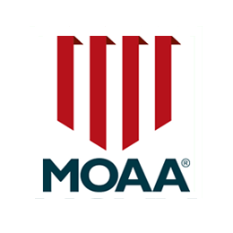
JROTC SCHOLARSHIP APPLICATION
VIRGINIA PENINSULA CHAPTER OF THE
MILITARY OFFICERS ASSOCIATION OF AMERICA (VIPMOAA)

Date of Submission: ______________________________________

Last Name_________________________________________________________________________

First Name ________________________________________________MI _____________________

Phone:____________________________________Email ___________________________________

Male Female

Home Address: _____________________________________________________________________

___________________________________________________________________________________

High School Name: __________________________________________________________________

JROTC Program Sr Instructor: _______________________________________________________

Phone:____________________________________ Email___________________________________

Post Secondary university, college, trade school, vocational school, or other certificate awarding program (accepted)

_______________________________________________________________________

Current HS Academic percentile rank: _________________________________________________
Free Application for Federal Student Aid (FAFSA) Student Aid Index (SAI):__________________
Provisional independent student status (if applicable)

For the following attach a separate statement of:

- JROTC achievements and honors.

- Extracurricular activities and honors, community activities/achievements/work, etc

- Cadet statement (1 page max) of your academic or training goals, answer the question “How will a VIPMOAA scholarship aid your educational/training goals?”

- Attach a statement of endorsement by your senior JROTC instructor

It is desired that page 1 of this application and the separate statements be combined into a master PDF document and emailed to tgswanson@cox.net by the 01 May 2026 deadline.

